ENVIRONMENTAL JUSTICE CLE: PUBLIC PARTICIPATION IN
DECISION MAKING

With Professor Robin Collin
Friday, September 22, 2017, 12:00 pm - 1:00 pm

Background Concepts:

Environmental Justice: Exposures to hazardous waste and pollution without knowledge, inclusion or consent of the people impacted. (Foundational empirical work by United Churches of Christ, 1987)
The best predictor of toxic and hazardous waste is the race of the community.
Racial communities ethnic communities under deliberate intentional assault from public policy housing, unemployment, poverty, lack of education, drugs, and pollution and waste

History of imposing risks on vulnerable, excluded populations through public policy decisions. (See works by Dr. Robert Bullard, and works by Robin M Collin and Robert W Collin)

Race, gender, class affect contemporary policy, legislation, and implementation regarding public exposure to hazardous waste and pollution. (See works by and relying upon Dr. Paul Slovic of Decision Research, an independent, nonprofit research corporation)

We are so connected by our environment – water, air, and what is in our lands – that what we do to one will affect the other. That means what we do to our lands affects our water affects our air; wat we do to one group of people circulates to affect all. We must not only stop treating poor communities and communities of color as sinks or dumps, even if that stopped today, we must rehabilitate them.

Environmental Injustice, Environmental Racism, Shared Adverse Impacts. Why Inclusion Matters, the Problems that arise from lack of inclusion in public decision making, why those problems will continue and grow. Examples of contemporary shared impacts from historically biased decisions.
Utilitarian decision making is an illusion. The greatest good for the greatest number is only valid if every affected party is considered. Exclusions mean that some benefit at the expense of others, and the greater the exclusions, the more likely it is that a few will benefit at the expense of the many.
When environmental decisions are made that impose risk and harms on people of color communities, children, poor communities, the elderly we are now talking about a majority of people; consider the additional burden of excluding a voice for plants and animals I the form of habitat, and it goes on.

The kinds of risks and harms that are commonly imposed this way are based on distribution of toxic wastes, and pollution from profit generating activities. The profits generated do not take into account – or pay for – known risks and harms externalized onto excluded communities who bear those costs and risks without consent or even knowledge. Also, benefits are commonly distributed in this way as well. Profit-generating activities do not take into account or defray known harms and risks of their activities which are externalized onto communities. Take the example of housing and the real estate market. As profits rise, houselessness increases. Yet, no profits are channeled directly into affordable housing. That occurs through taxing of the majority who didn’t participate in the profits generated.

Public Participation in Environmental Decision Making: Current Legal Treatment (Oregon and beyond)

Environmental Justice as both procedural and substantive analysis.

Environmental justice refers to the distribution of environmental rights and benefits by race, class, and income. These include substantive rights like clean air and water, and process rights like notice and the opportunity to participate in environmental decision making.

Polices and laws about Environmental Justice have developed in the US at both state and federal levels , and also internationally.

We will focus on the development of environmental justice activities in Oregon. See, Environmental Justice in Oregon: It’s the Law, http://elawreview.org/articles/volume-38/issue-38-2/environmental-justice-in-oregon-its-the-law/

Oregon’s statutes, 5 ORS 182.535 to 182.550 https://www.oregonlaws.org/ors/182.535 require the natural resource agencies of Oregon to consider the environmental justice impacts of their conduct, and also to involve environmental justice communities in their decision making. 5 ORS 182.542

2015 ORS 182.545¹
Duties of natural resource agencies
In order to provide greater public participation and to ensure that all persons affected by decisions of the natural resource agencies have a voice in those decisions, each natural resource agency shall:
(1) In making a determination whether and how to act, consider the effects of the action on environmental justice issues.
(2) Hold hearings at times and in locations that are convenient for people in the communities that will be affected by the decisions stemming from the hearings.
(3) Engage in public outreach activities in the communities that will be affected by decisions of the agency.
(4) Create a citizen advocate position that is responsible for:
(a) Encouraging public participation;
(b)Ensuring that the agency considers environmental justice issues; and
(c)Informing the agency of the effect of its decisions on communities traditionally underrepresented in public processes. [2007 c.909 §4]
Note: See note under 182.535 ("Natural resource agency" defined for ORS 182.535 to 182.550).

Thanks to Senator Avel Gordley, Robert W. Collin who has taught EJ at all three Oregon law schools and is the author of the preeminent article on EJ in Oregon.

I have included a basic format for substantive EJ analysis in the materials below. Our focus for the remainder of this discussion will be on the procedural aspects of inclusion.

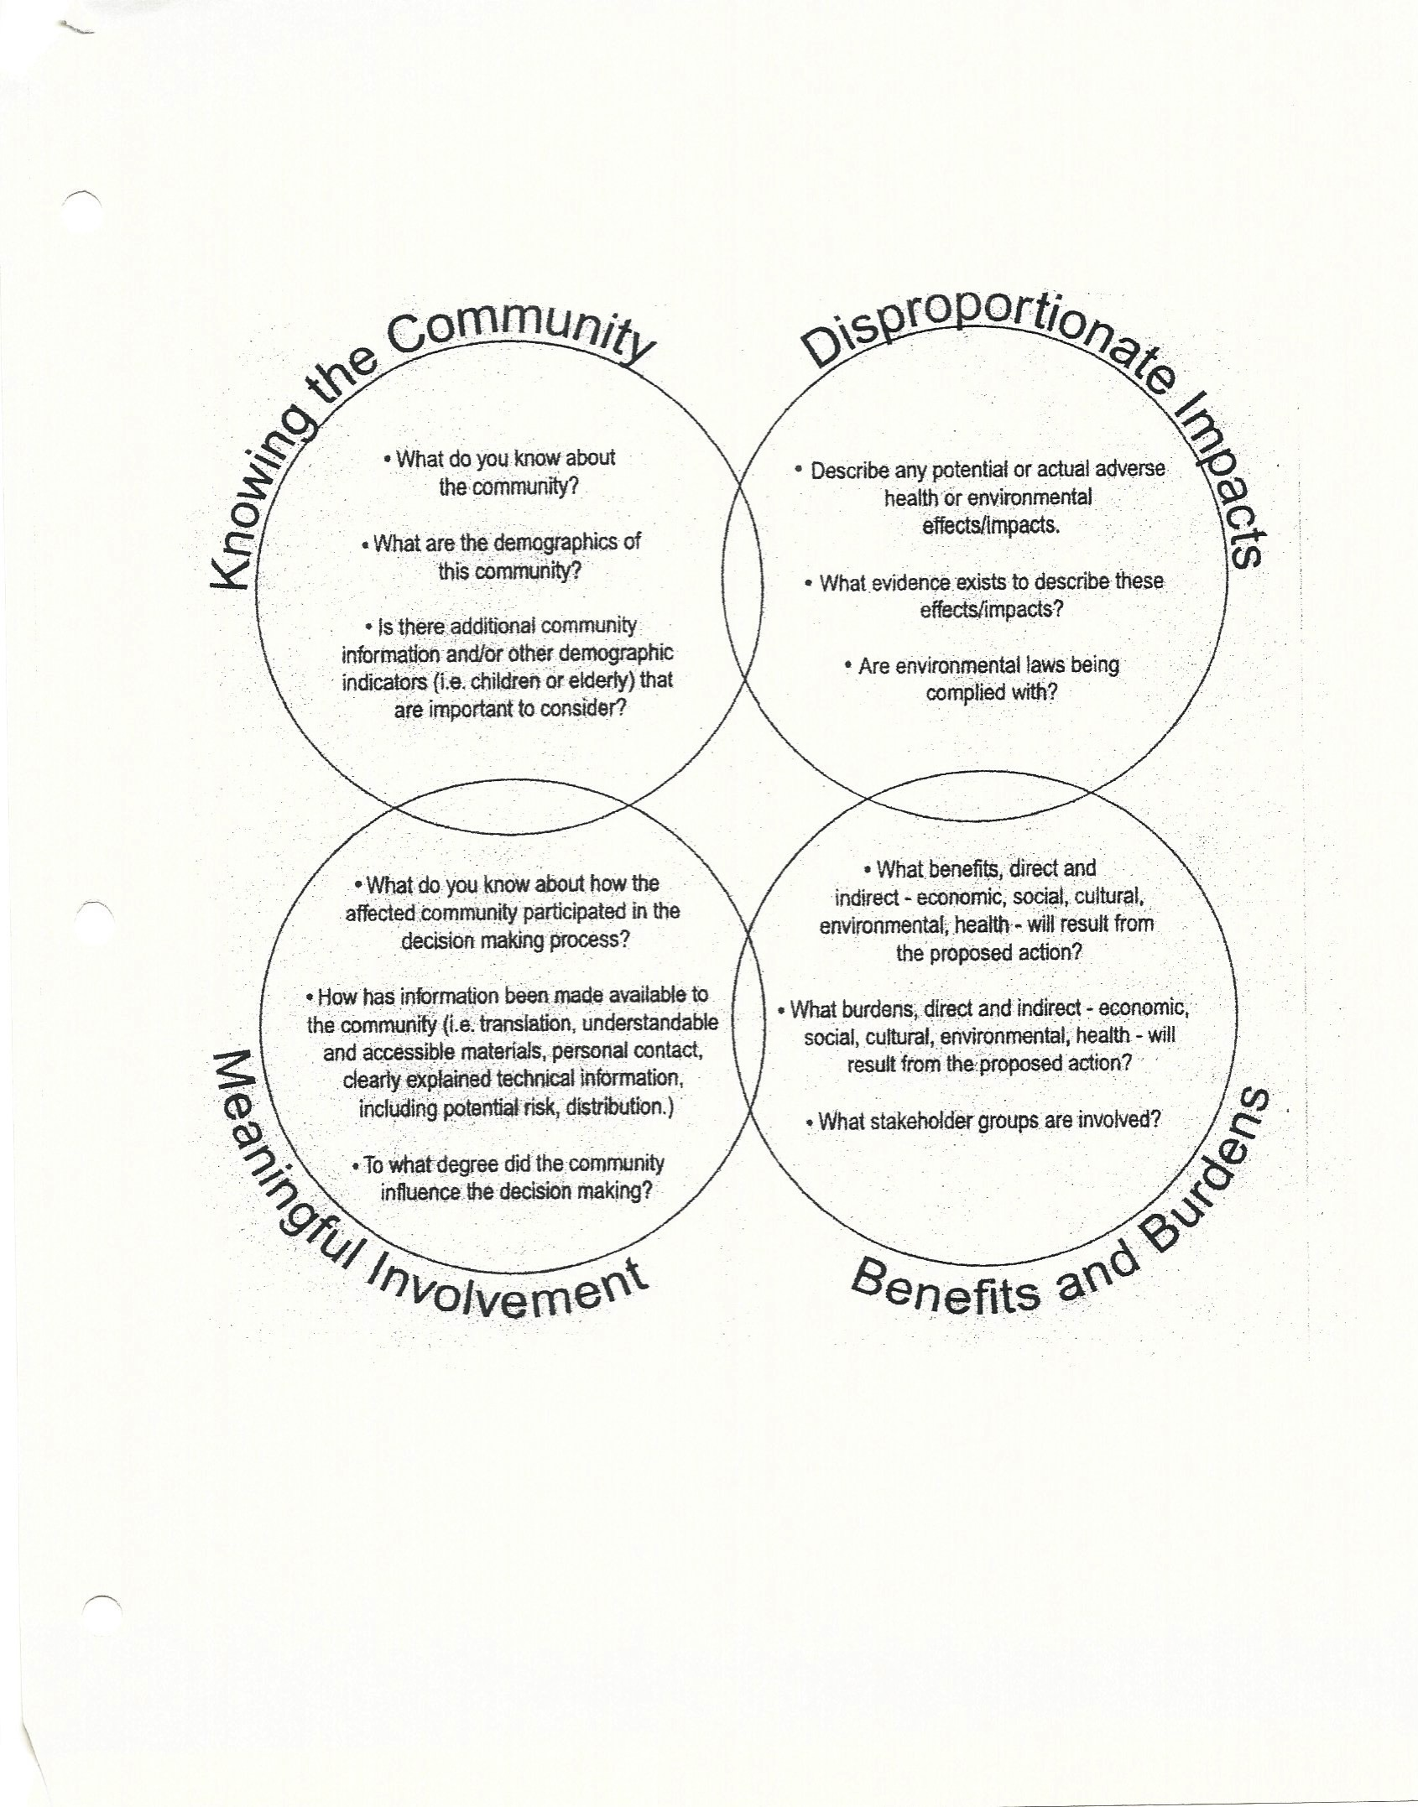
Figure 1 Substantive Environmental Justice Analysis

Constructing Public Participation: EJ Principles and Tools

Principles:
- Accountability, Transparency and Openness
- Continuing Challenge of Capacity in Governmental agencies to convene and host and in community partners.
- Listening, culturally competent facilitation, and commitment to fully inclusive discourse.

Three Environmental Justice Public Participation Tools:
- Scorecard,
- Best Practices Handbook,
- EJScreen.

Integrating EJ Principles and Tools

Scoping, An Iterative Process (you are never completely finished): identifying the decisions to be made, conceptualizing the processes to be used, identifying the convenor, identifying the stakeholders, establishing the timelines, clarifying supporting roles for facilitation and technical education and support.

Using scorecard.org and EJ Screen to identify issues for communities and stakeholders in communities

Cultural competence in outreach and facilitation, including poverty and digital access

Building capacity in all stakeholders, including internal coordination of convenor, and community capacity.

Welcoming all, welcoming late comers, building principles of trust and mutual commitment to respect.

Public Participation Planning

Outreach and the Best Practices Handbook

Cultural competence in outreach and facilitation, including poverty and digital access

Building capacity in all stakeholders, most challenging first

Welcoming all, welcoming late comers, building principles of trust and mutual commitment to respect.

Consideration of Public Inputs (wait, you aren’t finished yet):

All forms of knowledge matter, including community interpretation of meaning

Planning for accountability to all stakeholders

inclusion of stakeholders who will be affected in determining how to measure success

An Example: Integrating Principles with Tools: Cleaner Air Oregon

Scoping and Capacity Building: The Problem and the Rulemaking

- http://cleanerair.oregon.gov/regulatory-reform/

- http://cleanerair.oregon.gov/regulatory-reform/technical-workgroup/

Identification of impacted communities and Capacity Building: Who is Missing?

- Advisory committee selection process

The advisory committee selection process was designed to reflect the range of stakeholders who will be affected by implementation of a new air toxics permitting program. DEQ and OHA identified 14 committee seats, which were filled by nominees from stakeholder organizations. An additional 10 seats were created based on input received from the public during a comment period that was open between May and July. For information on what input was requested, please refer to Cleaner Air Oregon: Request for Input on Advisory Committee Positions.
A total of 41 applications were received for the following 10 seats established in response to public input:
• Physicians association or healthcare advocacy organization
• Professional health association
• Neighborhood-level community based group (Preference will be given to groups willing to represent multiple geographic community-based coalitions.)*
• Neighborhood-level community based group (Preference will be given to groups willing to represent multiple geographic community-based coalitions.)*
• Business owner of a small business with fewer than 50 employees*
• Business owner of a small business with fewer than 50 employees*
• Business owner of a large business with more than 50 employees*
• An industry union representative
• An engineer or individual with experience in pollution control technology for air toxics
• An academic with expertise relevant to this rulemaking

Each of Oregon’s nine federally-recognized tribes also has the opportunity to designate an additional committee member.

Additionally, agency directors appointed two co-chairs to the advisory committee: Jackie Dingfelder and Claudia Powers. The role of the co-chairs is to implement a process that focuses the committee on intended outcomes and ensures all perspectives are considered and provides transparency.

- http://cleanerair.oregon.gov/participate/

Modes of Inclusion; inadequacies of notice and comment format as well as traditional presentation format. Outreach, Event planning for Discourse: Importance of the Host’s cultural (race, class, and gender) competence and Capacity Building

http://cleanerair.oregon.gov/regulatory-reform/

Inclusion in Data Collection and Curation: What Counts as Knowledge and Information

- http://cleanerair.oregon.gov/data-and-current-actions/

Accountability to Participants, Measurements of Success, and Interpretation of Meaning

- http://cleanerair.oregon.gov/data-and-current-actions/http://cleanerair.oregon.gov/data-and-current-actions/

https://www.nrc.gov/docs/ML1310/ML13109A339.pdf (page last visited August 27, 2017).
https://www.amazon.com/Robert-D.-Bullard/e/B001ITYMI8/ref=dp_byline_cont_book_1 (page last visited August 27, 2017).
https://papers.ssrn.com/sol3/results.cfm (page last visited August 27, 2017). https://www.amazon.com/Robin-Morris-Collin/e/B00QMXSMZO (page last visited August 27, 2017).
https://www.researchgate.net/scientific-contributions/3538060_Paul_Slovic; https://www.ncjrs.gov/criminal_justice2000/vol_3/03j.pdf (page last visited August 27, 2017).
24th Annual Martin Luther King Jr. Breakfast, January 2010. (Standing ovation from Senator Ron Wyden, Representative Blumenauer and others in attendance.) Address available online at http://www.theskanner.com/npmtc-news/24018-24th-annual-martin-luther-king-jr-breakfast (page last visited September 17, 2017).
Environmental Justice in Oregon: It’s the Law http://elawreview.org/articles/volume-38/issue-38-2/environmental-justice-in-oregon-its-the-law/. (page last visited August 28, 2017.)
Federal Executive Order 12898 https://www.epa.gov/laws-regulations/summary-executive-order-12898-federal-actions-address-environmental-justice. (page last visited August 28, 2017.)
Title VI of the Civil Rights Act, https://www.epa.gov/ocr/title-vi-and-environmental-justice-epa, see also Title VI and Adam Clayton Powell https://www.youtube.com/watch?v=t5kCqRoshwc (page last visited August 28, 2017.)
The Aarhuus Convention http://ec.europa.eu/environment/aarhus/. (page last visited August 28, 2017.)
http://tenpowerfulthingstosay.com/TellMeMore.pdf (page last visited August 28, 2017.)
http://www.scorecard.org (page last visited August 28, 2017.)
http://www.oregon.gov/gov/policy/environment/environmental_justice/Documents/2016 Oregon EJTF Handbook Final.pdf - Best Practices Handbook (page last visited August 28, 2017.)
https://www.epa.gov/ejscreen (page last visited August 28, 2017.)
Background Context to Cleaner Air Oregon rulemaking, See http://koin.com/2016/04/21/deq-announces-temporary-glass-regulations/)

